**Load balancer**

**--------------------------------------------------------------------------------------------**

**1.Configure Classic Load balancer**.

1.Create 2 instances with user data 1. HTTP 2 Nginx

2.Go to Ec2 Service

Create load balancer 🡪Select classic load balancer 🡪 Give uniqename

Choose internet-facing 🡪Listener Configuration**🡪 HTTP 80 HTTPD 443**

**Configuration health check:** Unhealthy threshold 🡪2 healthy threshold 🡪3

Add the instance in Load balancer and create.

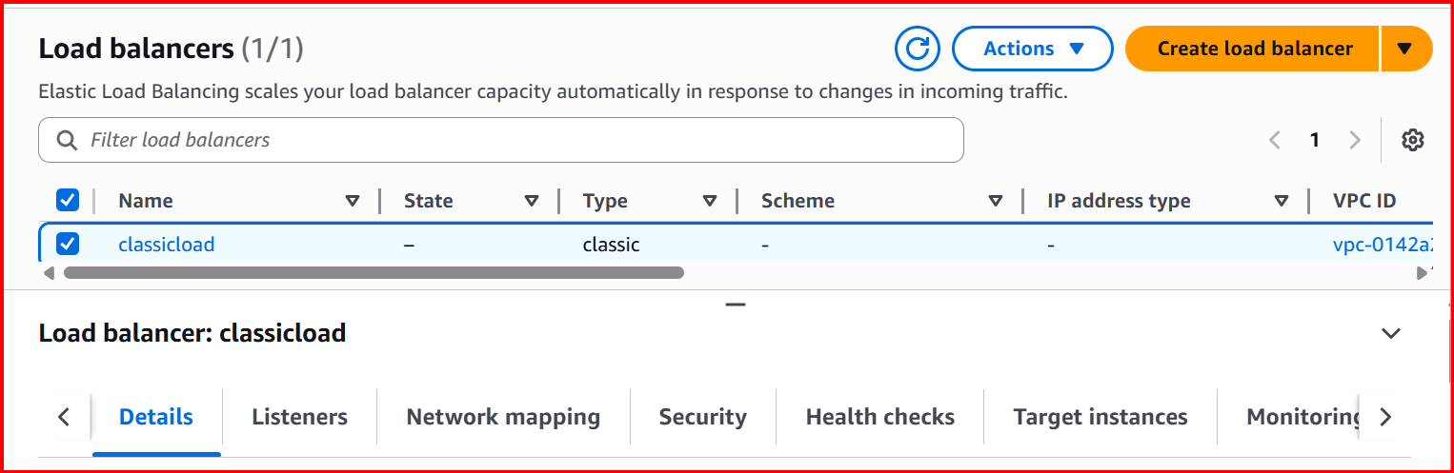

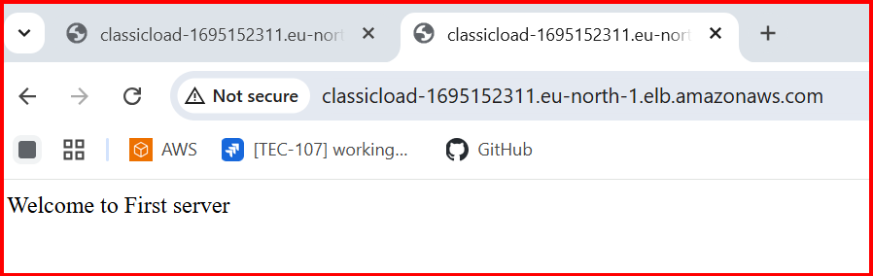

In Second instance I have install Nginx, added the second instance in Loadbalancer and wait for few mints and refresh the Browser. You can see the Nginx page.

First time welcome to first server and second time Nginx page will display.

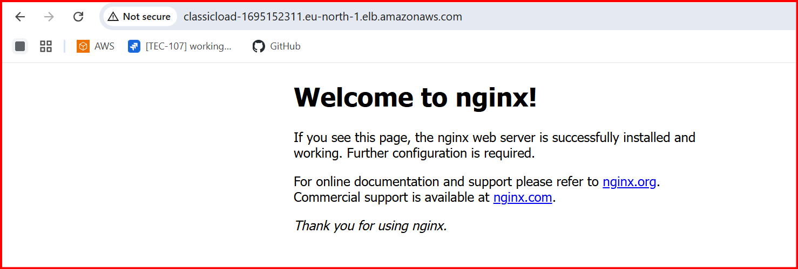

**2.Configure Application Load balancer.**

Create two instances and choose the two different subnets 1a & 1b

Add the userdata for two instances

Create application load balancer:

EC2-> Loadbalancer 🡪 Choose 🡪 Application load balancer

* Target group

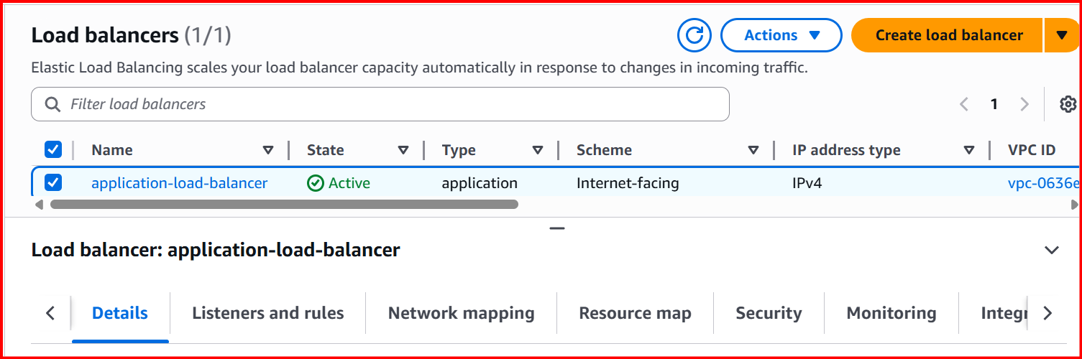

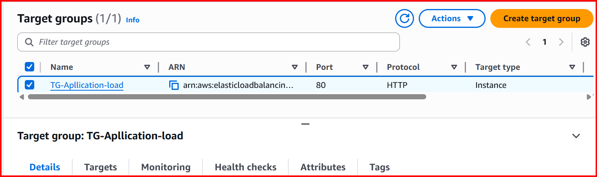

**Check with DNS:**

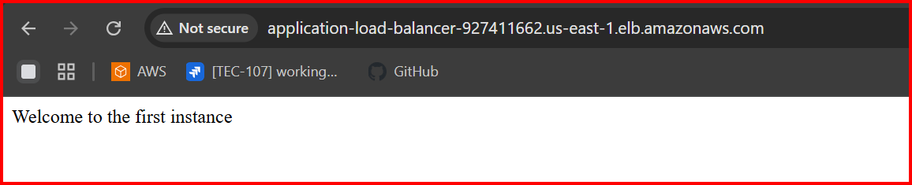

**Connect first instance**

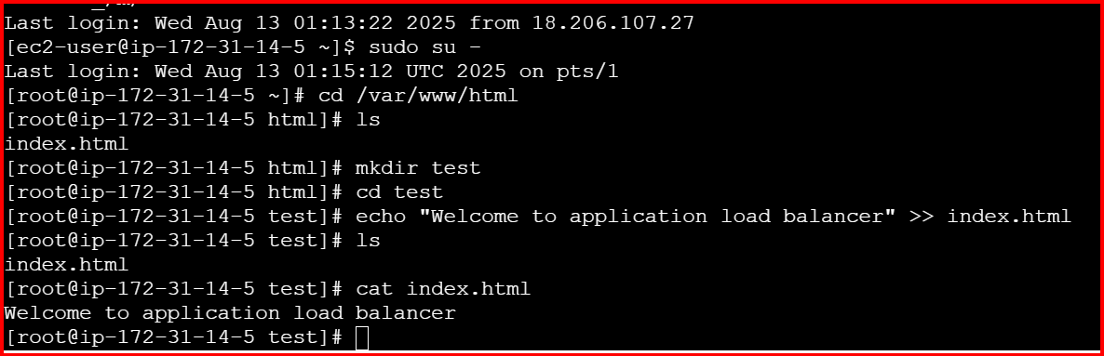

**In target group add rule**

**/test\***

**Check with /test**

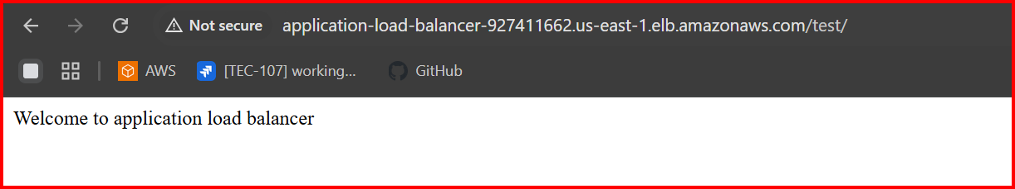

**3.Configure Network Load balancer.**

Create one instance: with user data

Create Target

**EC2 ---> Target groups ---> create target group**

Select **instance** in Target type

Select Protocol **TCP** Port **80**

Select **VPC** which is in used instances

Select **IPv4** in IP address type

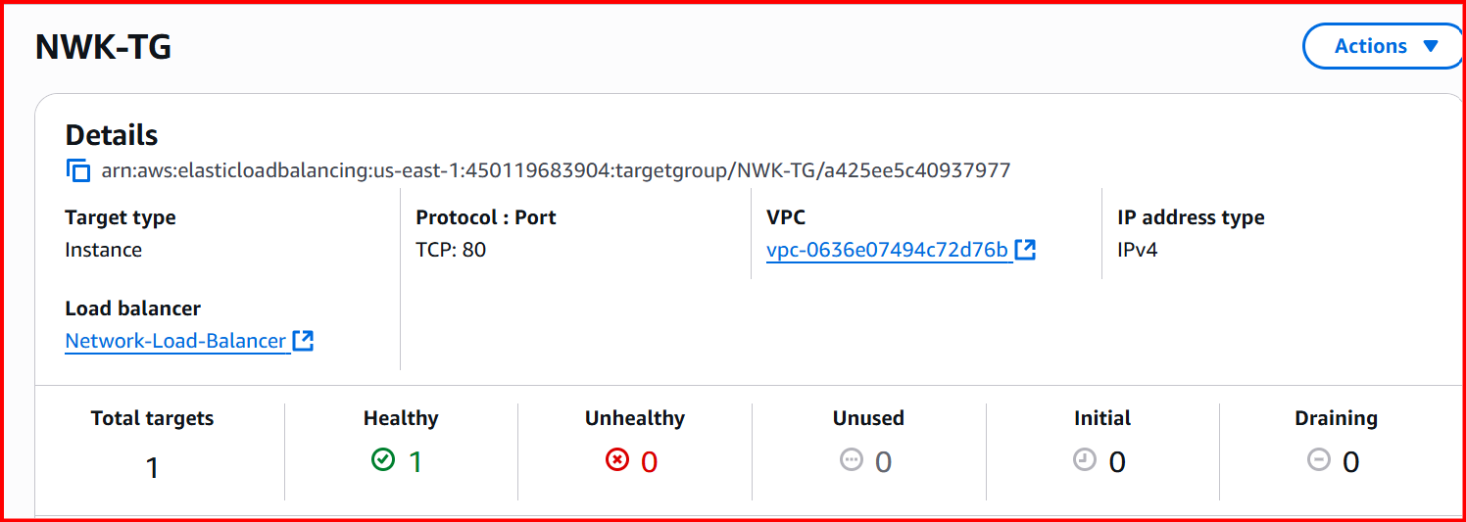

**create load balancer --->** select **Network load balancer**

Enter **Load balancer name**

Select **internet-facing** in **scheme**

Select **IPv4** address type

Attach your **Target groups** in **Listeners and routing**

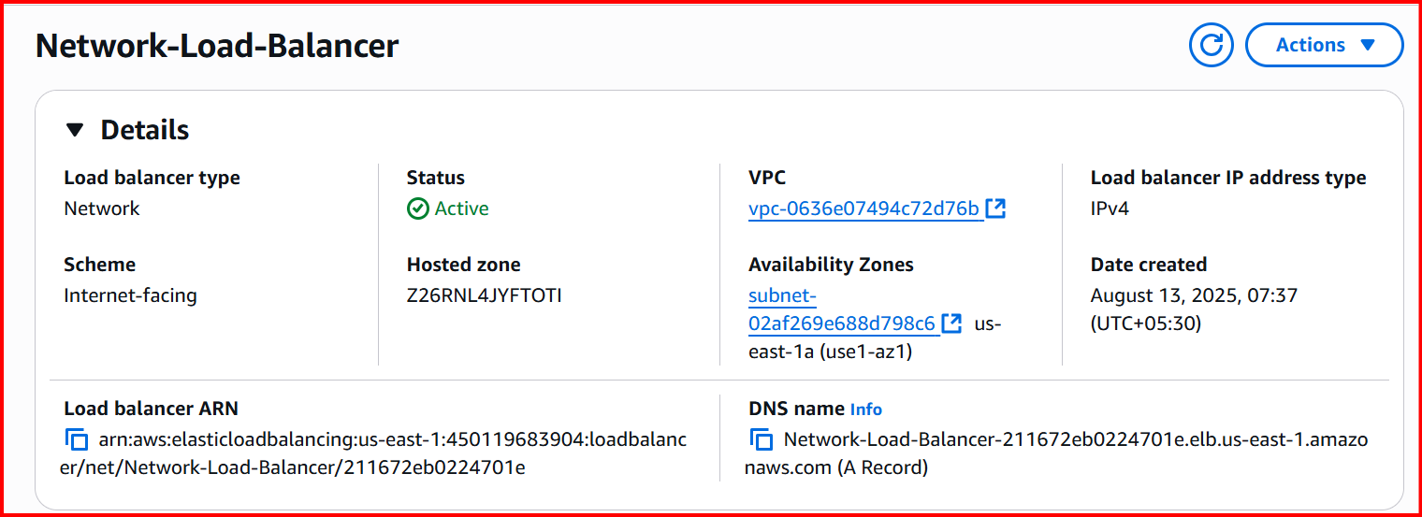

**Copy the DNS name and paste in the Browser**

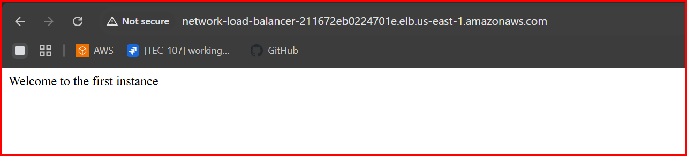

**4.Attach SSL for application load balancer.**

Go to AWS Certificate Manager (ACM) in the AWS Console.

Click Request a certificate → Request a public certificate.

Enter your domain name(s) (e.g.,: yunusdevops.shop).

Wait until the certificate status shows Issued

Go to **EC2 → Load Balancers** in AWS Console

Select your **Application Load Balancer**.

Go to the **Listeners** tab.

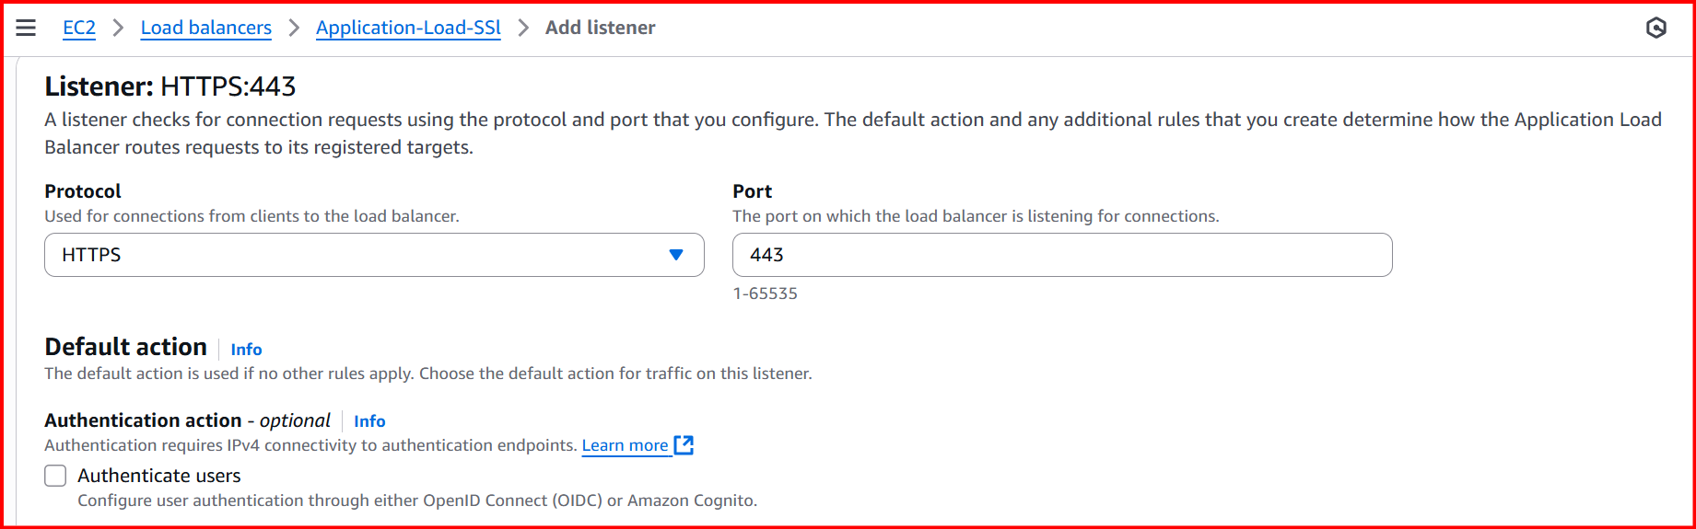

**Select the certification**

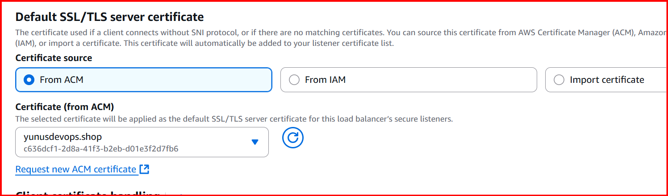

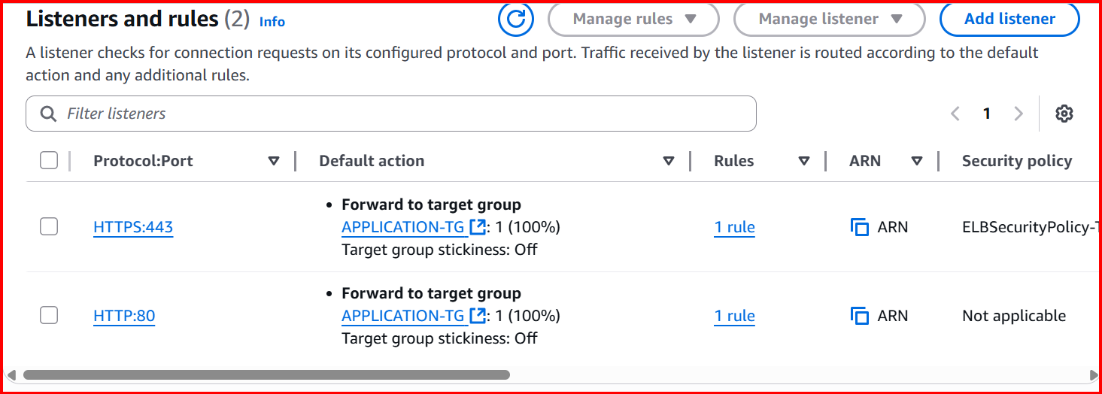

**5.Map Application load balancer to R53.**

Go to Route 53 → Hosted zones

Create a record

Record name: blank

Record type: A — IPv4 address

Alias: Yes.

Route traffic to: Alias to Application Load Balancer.

Region: Select the same region as your ALB.

Choose load balancer: Select your ALB from the dropdown.

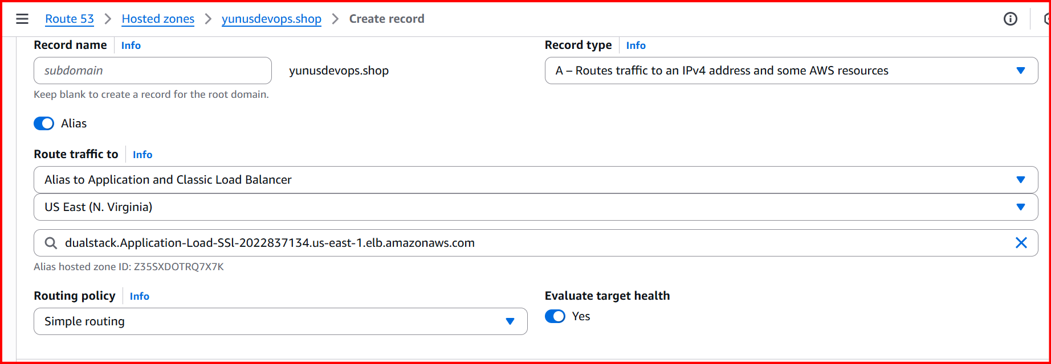

In Certificates add route 53: Add C Name , Value

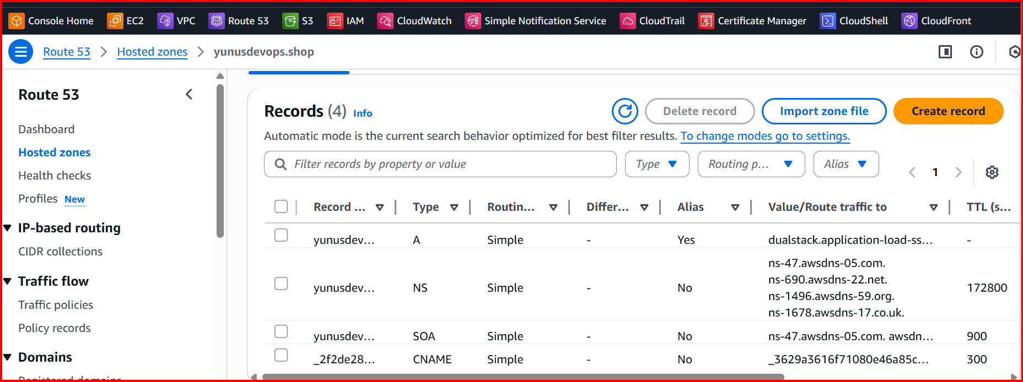

Check with domain name: Yunusdevops.shop

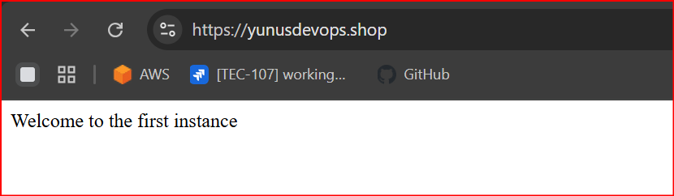

**6. Push the application load balancer logs to s3.**

Create S3 Bucket

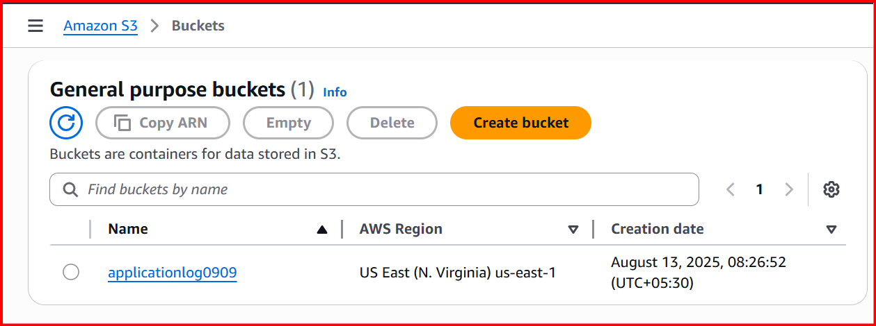

**Bucket Policy:**

**{**

**"Version": "2012-10-17",**

**"Statement": [**

**{**

**"Sid": "AWSALBLoggingPermissions",**

**"Effect": "Allow",**

**"Principal": {**

**"Service": "logdelivery.elasticloadbalancing.amazonaws.com"**

**},**

**"Action": "s3:PutObject",**

**"Resource": "arn:aws:s3:::applicationlog0909/AWSLogs/450119683904/*"**

**}**

**]**

**}**

**Go to AWS EC2 Console → Load Balancers.**

**Select your ALB.**

**Go to Attributes tab.**

**Find Access logs → Click Edit.**

**Turn Access logs ON.**

**S3 location: s3://<bucket-name>**

